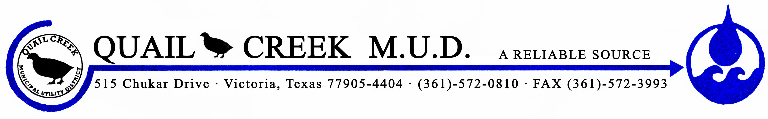

The Texas Commission on Environmental Quality (TCEQ) has notified the QUAIL CREEK MUD water system that the drinking water being supplied to customers had exceeded the Maximum Contaminant Level (MCL) for Arsenic. The U. S. Environmental Protection Agency (U.S. EPA) has established the MCL for arsenic at 0.010 milligrams per liter (mg/L) based on running annual average (RAA), and has determined that it is a health concern at levels above the MCL. Analysis of drinking water in your community for arsenic indicates a compliance value in quarter two 2023, of 0.013 mg/L for EP001.
This is not an emergency. However, some people who drink water containing arsenic in excess of the MCL over many years could experience skin damage or problems with their circulatory system, and may have an increased risk of getting cancer.
You do not need to use an alternative water supply. However, if you have health concerns, you may want to talk to your doctor to get more information about how this may affect you.
We are taking the following actions to address this issue:
The Quail Creek Municipal Utility District is monitoring the arsenic levels in all three wells and will be blending the water to better manage the levels or arsenic in the water that is supplied to the district.
Please share this information with all people who drink this water, especially those who may not have received this notice directly (i.e., people in apartments, nursing homes, schools, and businesses). You can do this by posting this notice in a public place or distributing copies by hand or mail.
If you have questions regarding this matter, you may contact Daniel Jimenez at 361-572-0810.

Posted/Delivered on: 06/30/2023

