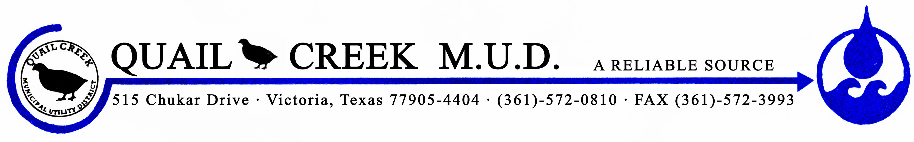

April 30, 2019

Dear Resident,

The Quail Creek MUD, PWS 2350004, failed to collect the required number of triggered source bacteriological samples for fecal indicator monitoring of the groundwater system during November 2017. This monitoring is required by the Texas Commission on Environmental Quality’s “Drinking Water Standards” and the federal “Safe Drinking Water Act,” Public Law 95-523.

Triggered source samples are used to monitor water quality and indicate if the water is free of fecal indicator bacteria. Following a positive routine total coliform result in our distribution system, our water system is required to submit one triggered source sample for every active groundwater well source. Failure to collect all required triggered source samples is a violation of the monitoring requirements and we are required to notify you of this violation.

What should I do?
There is nothing you need to do at this time.

What is being done?
A repeat sample was taken the next day from the same location and the results came back absent. Precautions have been taken and extra sample sites have been added to the list.
For more information, please contact Daniel O. Jimenez at 361-572-0810 or 515 Chukar Drive, Victoria, TX 77905.

Sincerely,

Daniel O. Jimenez
District Manager
Quail Creek MUD

